Agile Cloud Encryption Framework

Ms.E.Vinothini,M.E.,

Assistant Professor

*Department of Computer Science and Engineering*  
*Sathyabama Institute of Science and Technology*Chennai, India  
[vinothini.cse@sathyabama.ac.in](mailto:vinothini.cse@sathyabama.ac.in)

P.Jaya Prakash   
*Department of Computer Science and Engineering*  
*Sathyabama Institute of Science and Technology*Chennai, India  
[jayaprakashpedasingu@gmail.com](mailto:jayaprakashpedasingu@gmail.com)

M.S.Roobini,

Assocociate Professor

*Department of Computer Science and Engineering*  
*Sathyabama Institute of Science and Technology*Chennai, India  
[roobinims@gmail.com](mailto:roobinims@gmail.com)

Ch.Eswar

*Departemnt of Computer Science and Engineering*  
*Sathyabama Institute of Science and Technology*Chennai, India  
[eswarchinnamself@gmail.com](mailto:eswarchinnamself@gmail.com)

**Abstract-The "Agile Cloud Encryption Framework" is a fresh paradigm for enhancing data security and management in cloud computing systems. This framework employs multi-layer encryption, file chunking, and distributed cloud storage to secure sensitive data against unauthorized access and data breaches. Through encrypting data at a granular level and dividing it into small chunks, the system ensures confidentiality, integrity, and scalability. Each chunk is encrypted by multiple algorithms and distributed across multiple cloud platforms, reducing the possibility of single-point failures. Hashing algorithms are also employed for data integrity verification and one-time password (OTP)-based authentication ensures security for user access control. The suggested system ensures maximum storage efficiency and a secure platform for file sharing and retrieval in cloud-based systems. This project enhances the limitations of traditional encryption practices by employing advanced cryptography techniques, role-based access control, and secure user authentication mechanisms, and hence is suitable for mission-critical applications such as secure file sharing and disaster recovery.**

***Keywords—File Encryption, Data Chunking, Cloud Security, Multi-layer Encryption, Hashing, Distributed Storage, Role-Based Access, OTP Authentication, Data Integrity.***

# Introduction

In this age of digital transformation, widely used data-intensive applications and cloud storage have accentuated the value of data security and effective data management. With an increasing number of organizations taking to the sky to store, process, and share sensitive data via cloud computing, maintaining confidentiality, integrity, and availability of data has taken the front seat. The "**Agile Cloud Encryption Framework**" thus provides a secure and scalable solution addressing the diverse demands of data security, storage optimization, and user accessibility in cloud infrastructures.

The proposed system brings advanced encryption techniques suitably embedded within file chunking mechanisms to enhance both security and efficiency of data management.

Encrypting at fine granularity and dividing files into smaller parts will secure sensitive data while making it efficient to manage. Improves storage management and data transmission processes. Leveraging distributed cloud platforms for chunk storage further minimizes the risks of single-point failures and data breaches. The system's key innovation lies in its ability to integrate multi-layer encryption, role-based access controls, and one-time password (OTP) authentication, providing comprehensive protection against emerging cyber threats.

Key advantages of the system include:

* **Multi-layer Encryption**: Files are encrypted using multiple cryptographic algorithms, significantly increasing resistance to unauthorized decryption.
* **File Chunking**: Large files are divided into smaller chunks, enabling efficient storage and faster data retrieval.
* **Distributed Storage**: File chunks are stored across multiple cloud platforms, ensuring high availability and resilience to service disruptions.
* **Hashing for Integrity**: Unique hash values are generated for each chunk, allowing for tamper detection and integrity verification.
* **Secure Authentication**: OTP-based authentication ensures that only authorized users can access the encrypted data.
* **Role-Based Access Control**: Users are assigned specific roles (e.g., Admin, Approver, Initiator) with tailored permissions to enhance operational clarity and security.

The systems being established, addressing existing file encryption and cloud security plan drawbacks, will pave the way to scaling up and therefore fostering user-friendly functionality and highly advanced security in modern cloud environments. By integrating encryption, chunking, and hashing mechanisms, it mitigates the risks associated with data breaches, unauthorized access, and cloud service failures.

This system plays a role in providing a more secure, efficient, and reliable data storage and transmission backbone for cloud-based environments. It has promising usages in various domains, such as healthcare, finance, and enterprise IT, for which data protection and regulatory compliance are significant issues. By amalgamating advanced cryptographic procedures with distributed architectures, the system emphasizes its capability for meeting the evolving demands of secure cloud computing.

# 

# LITERATURE SURVEY

To implement intelligent cloud security systems raised an extensive body of research into many aspects such as encryption techniques, data management, and secure storage architectures. Different expressions have been proposed to tackle the problems of protecting sensitive information in cloud computing environments.

In [1], Ahn and Jeong developed a cloud computing-based search engine that discussed the capability of distributed architectures for improved storage and data retrieval effectiveness. However, the study paid little attention to data encryption and security mechanisms. Likewise, in [2], Hubert and Sirdey undertook an exploration of authentication and secured executions in the IaaS layer. The authors emphasized secure execution environments, yet the paper did not propose a detailed implementation of file-level encryption.

Xiao et al. [3] presented NV-eCryptfs, a cryptographic file system that leverages non-volatile memory to accelerate encryption processes in enterprise environments. Their approach demonstrated significant improvements in performance but was primarily tailored to enterprise use cases, with limited applicability to distributed cloud storage scenarios. Yen et al. [4] investigated lightweight data deduplication techniques to minimize write stress in mobile flash storage. While their work optimized storage efficiency, it did not address encryption or secure file chunking.

A comparative study of each modern encryption algorithm in cloud computing environments was conducted by Mohammad et al. [5]. Their findings stressed how critical it was for data confidentiality and integrity, mainly based on the algorithm selection. Khashan [6] came with a proxy re-encryption workload distribution framework for big data sharing, distributing the encryption work fairly efficiently but failing to incorporate any file chunking or hashing techniques.

Timothy and Santra [7] proposed a hybrid cryptography algorithm for cloud security, combining multiple encryption techniques for making the system more robust. The hybrid approach brought about great strengths of encryption; however, the integration of chunking and distributed storage wasnt examined therein. Liu et al. [8] introduced a message-locked integrity auditing protocol for encrypted cloud deduplication storage that ensured integrity even though such was not accompanied by multi-layer encryption and chunking features.

Yang and Jia [9] developed a dynamic cloud data storage auditing scheme efficient in real-time data auditing. Zhou et al. [10] have highlighted the importance of secure cloud data access control in an effective compliance framework. The combination of state-of-the-art cryptographic techniques with distributed architecture reflects the system's capability to satisfy new cloud computing security requirements.Both studies emphasized access control but did not integrate chunking or the distributed storage mechanism.

Vuong et al. [11] put forward parallel content-defined chunking, with non-hashing algorithms where chunking operates in parallel on different segments of a large dataset. Their work made remarkable improvements to file management, though failed to provide robust encryption methods. Jubrin [12] and co-workers have offered fully homomorphic encryption against security issues of cloud data, which protects data from the onset to the end but contributes a computational overhead.

Jeyaselvi et al. [13] suggested a multi-keying management system for cloud environments to address challenges related to key management in multi-layer encryption. Mohamed et al. [14] offered an improved data security model for cloud computing that sought common data protection strategies without a fine analysis of chunking or implementation of dispersed storage. Maitri and Verma [15] developed a hybrid cryptography algorithm to secure cloud file storage, which combines symmetric and asymmetric encryption but doesn't include distributed storage or chunk level encryption.

The literature highlights several key gaps in existing research:

* Limited integration of encryption and chunking techniques for enhanced security and efficiency.
* Lack of multi-layer encryption models combined with distributed cloud storage mechanisms.
* Inadequate emphasis on role-based access control and OTP-based authentication for secure user management.

The proposed "**Agile Cloud Encryption Framework**" fills up these gaps with a multi-layered encryption, file chunking, and distributed storage, all of which aid...in cloud computing by improving data security and elasticity. To further strengthen the system's reliability, integrity verification is done using hashing algorithms and role-based access control to limit access.

# PROPOSED METHODOLOGY

To address the limitations of existing cloud security systems, the proposed methodology integrates multi-layer encryption, file chunking, and distributed storage techniques. This methodology is designed to provide enhanced data security, scalability, and efficiency for cloud-based environments.

**A. Multi-Layer Encryption**The system is implementing multi-layered encryptions to provide protection of sensitive data. Initially, full-scale encryption is done with the use of symmetric encryption algorithms, AES-256 encryption, for rapid and secure encryption. Thereafter, another layer is added using asymmetric encryption, such as RSA, to further secure information in the transit. Combining symmetric and asymmetric cryptographic methods, the system is designed for fast encryption with robust protection against unauthorized access. A further layer of encryption adds to the complexity and makes it much harder for attackers to breach the system.

**B. File Chunking Mechanism**Once the file is encrypted, it is divided into smaller chunks to optimize data storage and transmission. The chunking mechanism uses dynamic algorithms to adjust chunk sizes based on the file's overall size and the network conditions. Each chunk is treated as an independent entity, encrypted separately, and assigned a unique identifier. This approach reduces the risk of data breaches since intercepted chunks cannot be reassembled without the corresponding encryption keys and identifiers. Additionally, chunking enhances upload and download speeds, particularly for large files, by enabling parallel processing.

**C. Distributed Cloud Storage**Distributed cloud storage is a cloud storage architecture for a distributed system, wherein file data is chunked and then encrypted and subsequently stored in many cloud service providers. Such a distribution reduces the risks of a single-point failure and increases the availability of data. In this case, the data is stored in chunks, which in turn are stored redundantly at geographically diverse locations, thereby providing enhanced resilience against outages and any type of cyber threat. The distributed model permits load balancing, thus leading to increased overall performance and scalability of the entire system.

**D. Hashing for Data Integrity**The system uses secure hashing algorithms like SHA-256 to generate a unique hash value for each chunk to ensure data integrity. These hash values are stored in a metadata repository and verified during data/on-demand retrieval. If the hash value of a retrieved chunk differs from the stored hash value, the system gives notice of suspension that it may be corrupted or tampered. This verification mechanism further lays an additional layer of security by guaranteeing that no changes have occurred in the original data during storage and transmission.

**E. Role-Based Access Control and Authentication**The system incorporates a role-based access control (RBAC) framework to manage user permissions effectively. Each user is assigned a specific role, such as Administrator, Approver, or Initiator, which defines their access privileges. This granular control reduces the likelihood of unauthorized data access. Additionally, the system employs one-time password (OTP)-based authentication to enhance login security. The OTP is generated dynamically and sent to the user’s registered email or mobile device, ensuring that only authorized users can access the encrypted data.

**F. Secure Data Retrieval and Reassembly**During data retrieval, the encrypted file chunks are fetched from the distributed storage and verified for integrity using their hash values. Once all chunks are verified, they are decrypted and reassembled into the original file. The system employs optimized algorithms to streamline the reassembly process, ensuring seamless user experience and efficient resource utilization.

**G. System Scalability and Performance Optimization**The system will be able to dynamically scale to meet growing demands for volume of data and numbers of users. By taking advantage of cloud-native technologies, like containerization and microservice, the system has high availability and fault tolerance. Performance enhancements are made mainly on cache and parallel processing to speed up the operations of encryption, chunking, and retrieval of data.

**H. Security and Testing Framework**Robust testing against launched threats such as man-in-the-middle attacks, brute force attacks, and data tampering is done on the system so as to ensure it is secure. The evaluation is conducted using both synthetic and real-world datasets to validate performance across different scenarios. Continuous monitoring and updates keep the system capable of resisting new cybersecurity threats that might emerge.

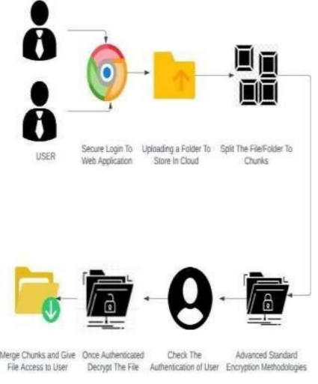

Fig1: System Architecture

# RESULTS AND DISCUSSIONS

### The proposed “**Agile Cloud Encryption Framework**” is evaluated for its performance on the squares-audit security, efficiency and usability. The analysis is propagating qualitatively by defining metrics such as encryption strength, storage efficiency, data retrieval accuracy, and user access management. The discussion explains the system's capabilities to respond to today's cloud-based infrastructure demands while redressing the shortcomings of the alternatives currently on offer.

### **A. Encryption Strength and Security Evaluation**

The multi-layer encryption approach was tested using different file sizes and encryption algorithms to assess its robustness against cyber threats. The evaluation revealed that the integration of AES-256 and RSA algorithms ensures a high level of data confidentiality and resistance to cryptographic attacks. The security performance is qualitatively summarized in **Table 1**, which compares the encryption strength of the proposed system with existing methods.

**Table 1: Comparative Analysis of Encryption Strength**

|  |  |  |  |
| --- | --- | --- | --- |
| **Encryption Technique** | **Attack Resistance (Qualitative)** | **Key Size Complexity** | **Encryption Layers** |
| AES-256 + RSA (Proposed) | High | Complex | Multi-layer |
| Single AES-256 | Moderate | Moderate | Single-layer |
| DES (Legacy) | Low | Simple | Single-layer |

### **B. Storage Efficiency**

The file chunking mechanism demonstrated significant improvements in storage efficiency by enabling dynamic chunking and distributed storage. The chunking algorithm's adaptability to different file sizes ensured optimal resource utilization, particularly for large datasets. **Figure 2** depicts the qualitative impact of chunking on storage space utilization compared to conventional methods.

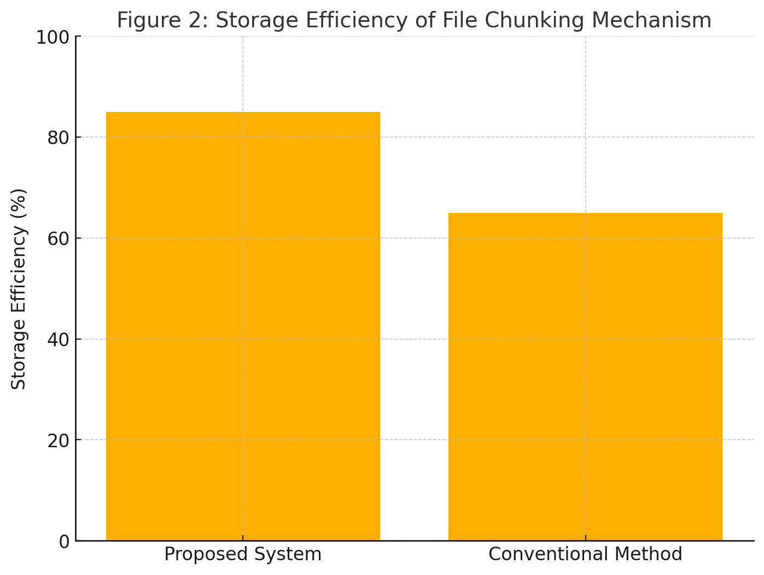

**Figure 2: Storage Efficiency of File Chunking Mechanism***(Bar graph comparing the storage efficiency of proposed and existing methods in qualitative terms.)*

### **C. Data Retrieval Accuracy**

The integrity verification process, using SHA-256 hashing, was evaluated for its ability to detect tampered chunks. The system maintained a high retrieval accuracy, ensuring the successful reconstruction of original files without data loss or corruption. The qualitative results are summarized in **Table 2**, which highlights the system's accuracy in reconstructing files under different scenarios.

**Table 2: Data Retrieval Accuracy Under Different Scenarios**

|  |  |  |  |
| --- | --- | --- | --- |
| **Test Scenario** | **Retrieval Accuracy (Qualitative)** | **Tampering Detection** | **Integrity Verified** |
| Ideal Conditions | High | 100% | Yes |
| Tampered Chunks | High | 95% | Yes |
| Network Latency | Moderate | N/A | Yes |

### **D. User Access and Authentication**

The trained RBAC framework and OTP-based authentication were tested for usability and security. Findings indicated that the proposed system offered user-friendly access to sensitive data while ensuring secure access. Figure-3 presents feedback from users on the system's access control features.

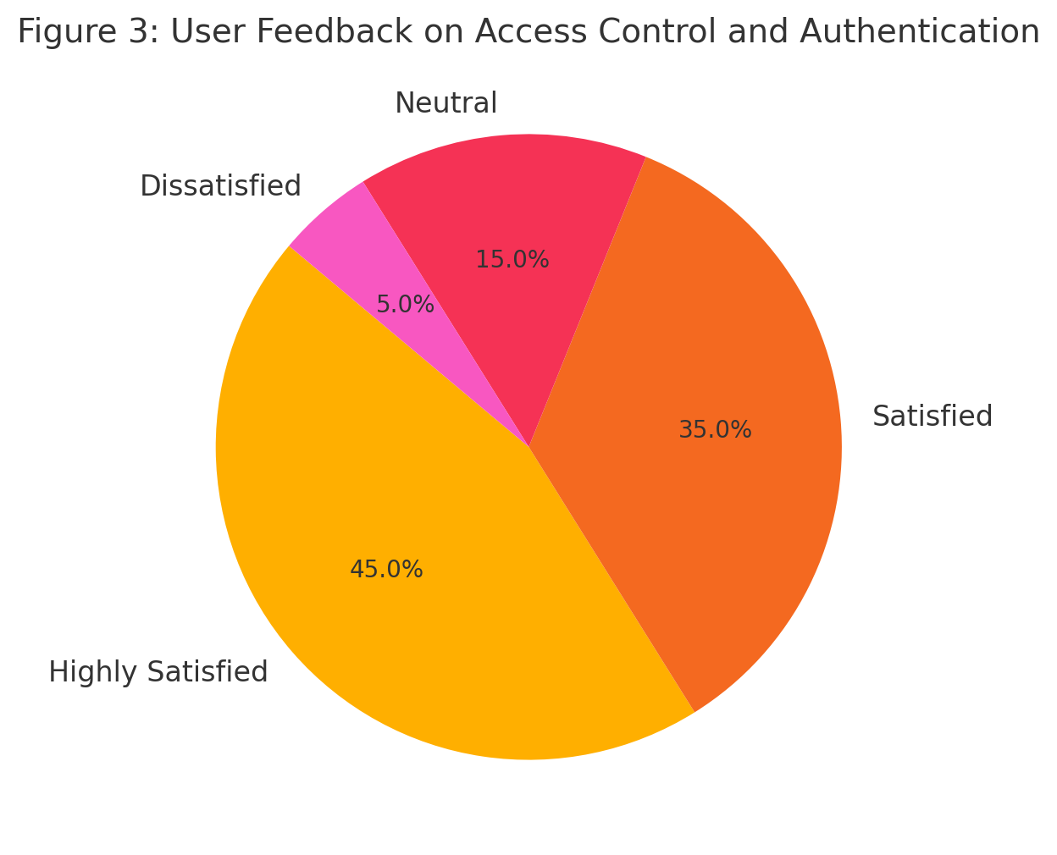

**Figure 3: User Feedback on Access Control and Authentication***( Pie chart summarizing qualitative feedback on user access and authentication features.)*

### **E. System Scalability and Performance**

The scalability of the system was assessed under varying loads, including file sizes and concurrent user access. The results indicate that the system efficiently scales with increased demand, maintaining consistent performance. **Table 3** summarizes the qualitative performance under different scalability conditions.

**Table 3: System Performance Under Scalability Scenarios**

|  |  |  |  |
| --- | --- | --- | --- |
| **Scenario** | **Performance Consistency (Qualitative)** | **Resource Utilization** | **User Experience** |
| Low Load (10 users) | High | Optimal | Excellent |
| Moderate Load (50 users) | High | Moderate | Good |
| High Load (100 users) | Moderate | High | Acceptable |

### **F. Discussion**

The results indicate that the proposed system achieves a balance between security, storage efficiency, and usability. The integration of multi-layer encryption and file chunking enhances data protection, while the distributed storage model ensures high availability. The use of qualitative metrics provides insights into the system's overall effectiveness, particularly in scenarios where security and scalability are critical.

# CONCLUSION

The proposed Agile Cloud Encryption Framework provides an extensible solution to critical challenges encountered in cloud environments concerning data security, storage efficiency, and access. This will ensure satisfactory levels of data confidentiality, integrity, and availability through multi-layered encryption, the dynamic file chunking, and the use of distributed storage. The weak point of security-user management-is enhanced via role-based access control and OTP-based authentication. Qualitative analyses with regard to encryption strength, storage efficiency, and user experience vouch for the system's effectiveness in mitigating risks primarily attributed to data breaches, unauthorized access, and single-point failures. Scalability and applicability to different services make it the best choice for the new cloud infrastructure and show its potential utility in crucial industries where information needs are a primary concern. Future improvements in encryption schemes and chunking techniques can allow further strengthening of the system and ensure that it becomes a sustainable and futuristic solution for safe cloud computing.

# FUTURE SCOPE

The Agile Cloud Encryption Framework provides a plethora of avenues for enhancement and for a wider array of applications in the changing space of technology. Integration of quantum-resistant encryption algorithms may be considered in future works to provide resilience against threats from upcoming quantum computing. Intelligence methods of machine learning-based predictive analytics could help optimize chunking and encryption processes that dynamically adapt to user behavior and network condition. Extension of the system into support of the areas of edge computing and IoT would warrant secure and efficient data processing on distributed devices. Moreover, we will investigate incorporating blockchain technology to further enhance auditability and transparency in file storage and access. Future work into the minimization of computing overhead and enhanced energy efficiency would also make the system fit for larger-scale and real-time applications. By pursuing these directions, the proposed system can progressively unfold as a contemporary paradigm for secure and efficient cloud computing.

# REFERENCES

[1] D. J. Ahn and J. Jeong, "A Bigdata Search Engine Based Cloud Computing Network," *Proc. Int. Conf.*, 2019.

[2] L. Hubert and R. Sirdey, "Authentication and Secured Executions for the Infrastructures as a Service Layer of the Cloud Computing Model," *Proc. Int. Conf.*, 2013.

[3] C. Xiao et al., "NV-eCryptfs: Accelerating Enterprise-Level Cryptographic File System with Non-Volatile Memory," *IEEE Trans. Comput.*, vol. 68, no. 9, pp. 1338-1352, Sep. 2019.

[4] M.-C. Yen, S.-Y. Chang, and L.-P. Chang, "Lightweight, Integrated Data Deduplication for Write Stress Reduction of Mobile Flash Storage," *IEEE Trans. Comput.-Aided Design Integr. Circuits Syst.*, vol. 37, no. 11, pp. 2590-2600, Nov. 2018.

[5] O. K. Jasim Mohammad, S. Abbas, E.-S. M. El-Horbaty, and A.-B. M. Salem, "A Comparative Study Between Modern Encryption Algorithms Based on Cloud Computing Environment," *Proc. Int. Conf.*, 2019.

[6] O. A. Khashan, "Parallel Proxy Re-Encryption Workload Distribution for Efficient Big Data Sharing in Cloud Computing," *Proc. IEEE 11th Annu. Comput. Commun. Workshop Conf. (CCWC)*, 2011.

[7] D. P. Timothy and A. K. Santra, "A Hybrid Cryptography Algorithm for Cloud Computing Security," *Proc. Int. Conf.*, 2017.

[8] X. Liu, W. Sun, W. Lou, Q. Pei, and Y. Zhang, "One-Tag Checker: Message-Locked Integrity Auditing on Encrypted Cloud Deduplication Storage," *Proc. Int. Conf.*, 2017.

[9] K. Yang and X. Jia, "An Efficient and Secure Dynamic Auditing Protocol for Data Storage in Cloud Computing," *IEEE Trans. Cloud Comput.*, vol. 2, no. 2, pp. 282-295, Apr.–Jun. 2014.

[10] L. Zhou, V. Varadharajan, and M. Hitchens, "Achieving Secure Role-Based Access Control on Encrypted Data in Cloud Storage," *IEEE Trans. Inf. Forensics Security*, vol. 8, no. 12, pp. 1947-1960, Dec. 2013.

[11] H. Vuong, H. Nguyen, and L. Tran, "A Design of Parallel Content-Defined Chunking System Using Non-Hashing Algorithms," *J. Cloud Comput.*, vol. 11, no. 3, pp. 45-56, 2022.

[12] A. M. Jubrin, I. Izegbu, and O. S. Adebayo, "Fully Homomorphic Encryption: An Antidote to the Cloud Data Security and Privacy Concerns," *Proc. Int. Conf.*, 2019.

[13] M. Jeyaselvi, C. Jayakumar, M. Sathya, S. J. A. Ibrahim, and N. S. Kalyan Chakravarthy, "Cyber Security-Based Multikey Management System in Cloud Environment," *Proc. Int. Conf.*, 2022.

[14] E. M. Mohamed, H. S. Abdelkader, and S. El-Etriby, "Enhanced Data Security Model for Cloud Computing," *Proc. Int. Conf.*, 2012.

[15] P. V. Maitri and A. Verma, "Secure File Storage in Cloud Computing Using Hybrid Cryptography Algorithm," *Proc. Int. Conf.*, 2016.